Exp no:10 Implement Boundary condition between two different dielectric medium in Magnetic Field and find the relative permeability of the different medium.
Aim: To write program for Boundary condition between two different dielectric media in magnetic field using SCILAB.
Software required: •SCILAB version 6.0.1
Coding:
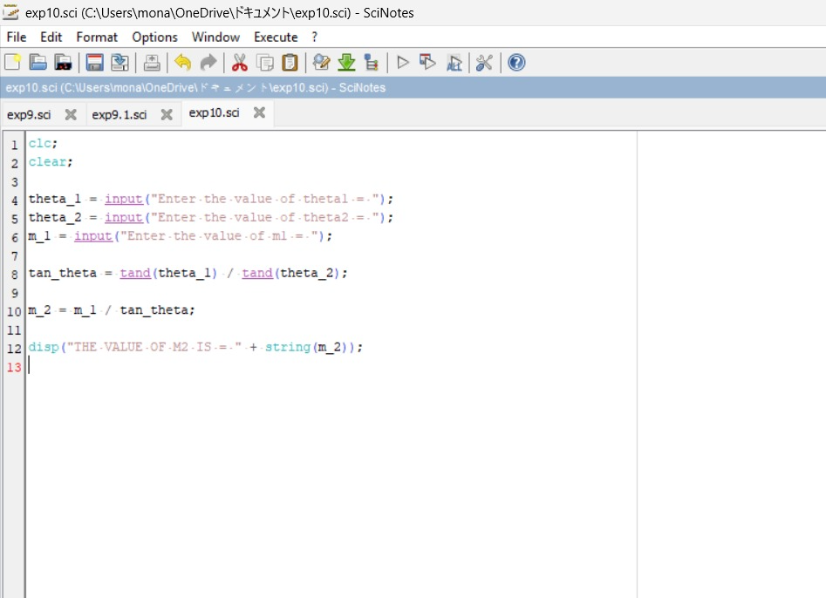
Calculation:
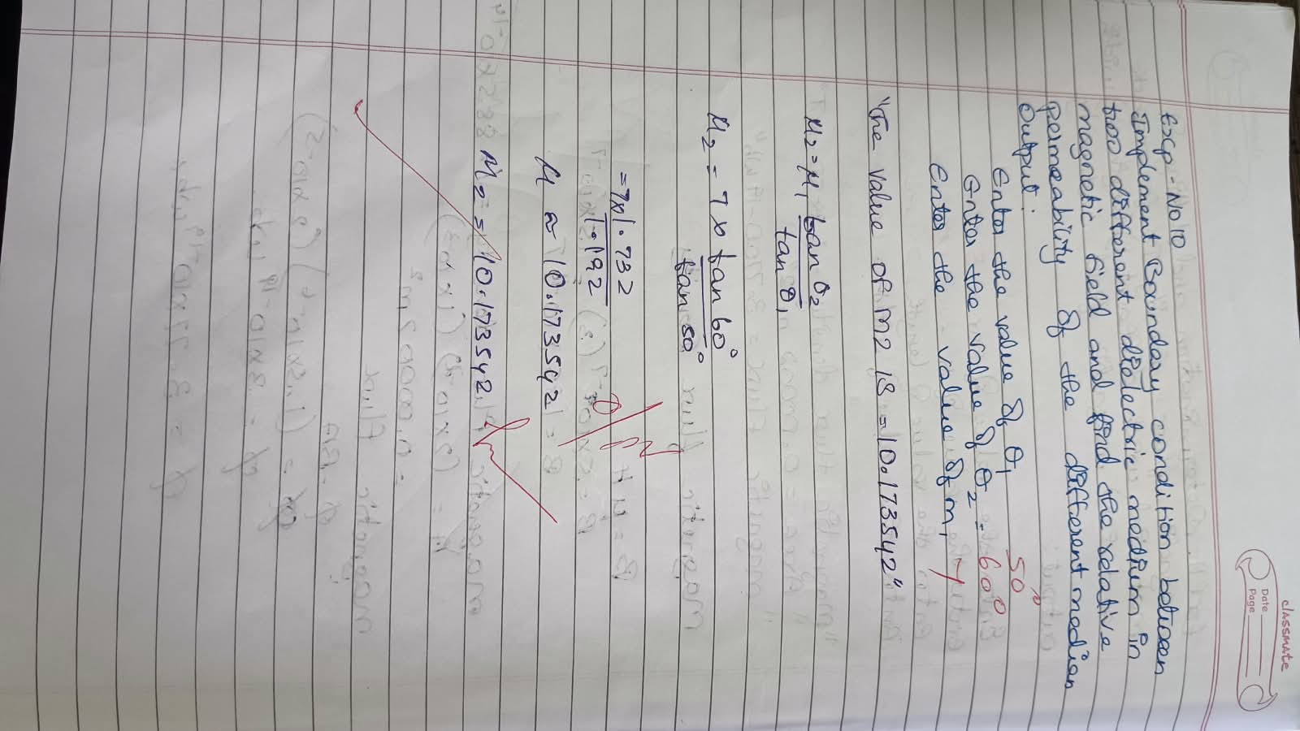

Output:
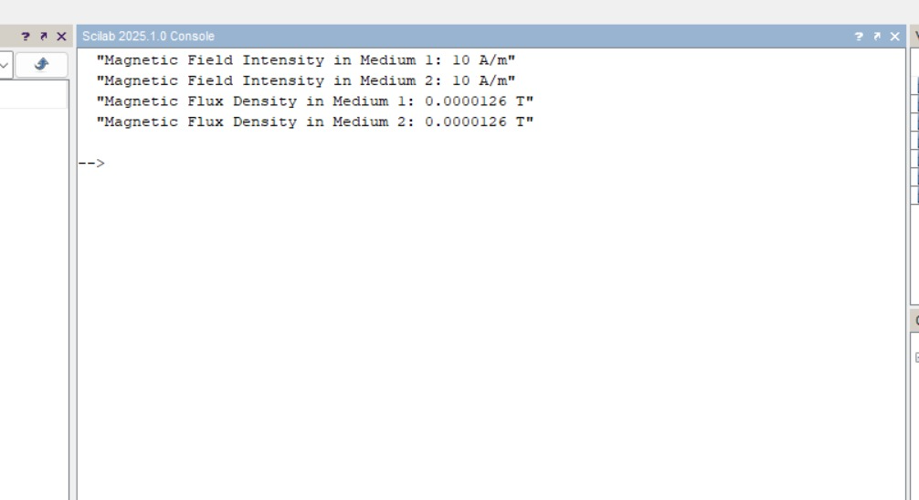

Case 1: Consider two identical media in the presence of a magnetic field. The relative permeability in both media is 1. What will be the effect of this on the magnetic field and flux density across the boundary?
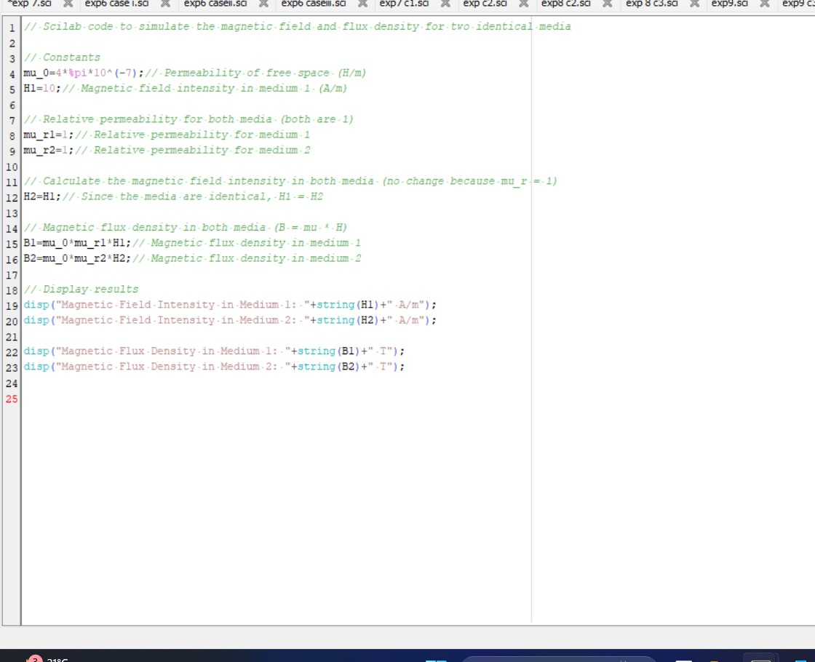
Output:
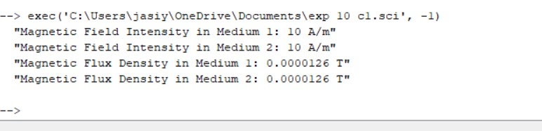
Case 2: In a system with two media, where the relative permeability of medium 1 is μr1=4 and medium 2 is a vacuum (μr2=1), how would the magnetic field intensity and flux density behave at the boundary?
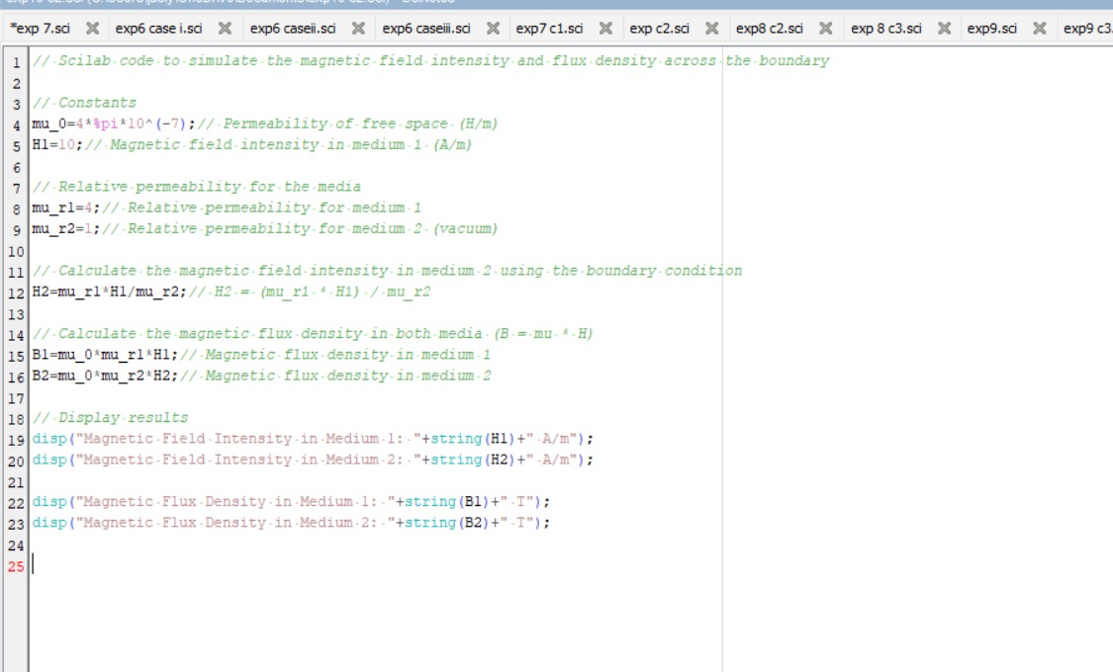
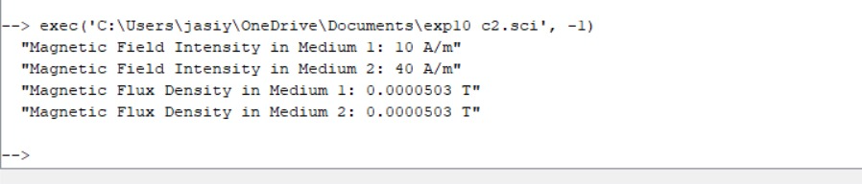
Case 3: If medium 1 has a relative permeability μr1=0.3 and medium 2 has a relative permeability μr2=2, calculate the magnetic field intensity in both media at the boundary if the magnetic field intensity in medium 1 is known to be H1=10 A/m.
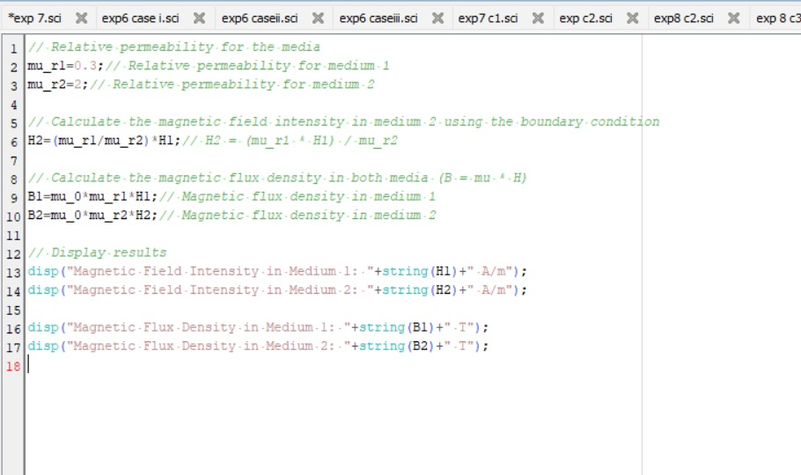
Output:
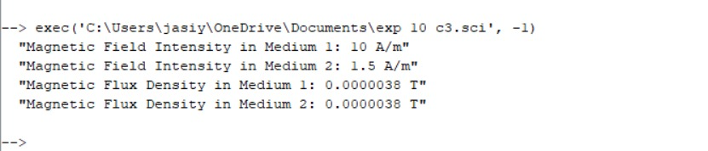

Result : Thus the effect of two different media on the magnetic field and flux density across the boundary is calculated.ssd

